GIT AND GITHUB -02

- Install git.
git init – it will initialize .git
git –version – it will show the version of git
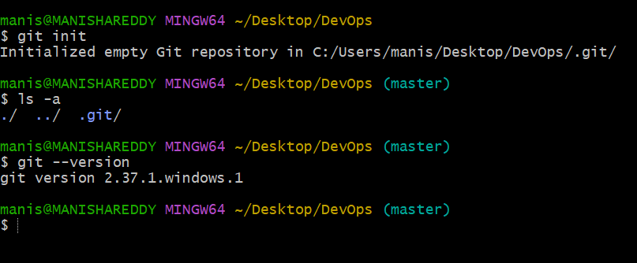

- Create a repo in github with README.md and .ignore file.
Go to Github click on new repository create repositories
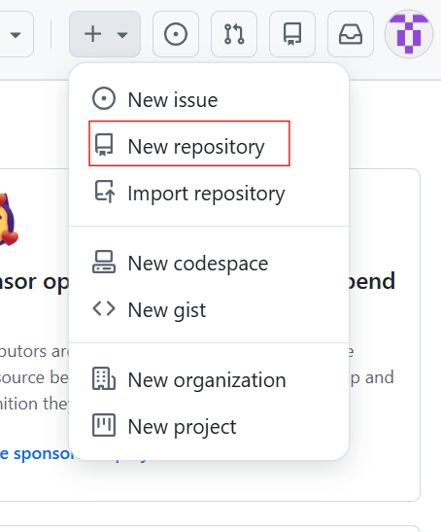
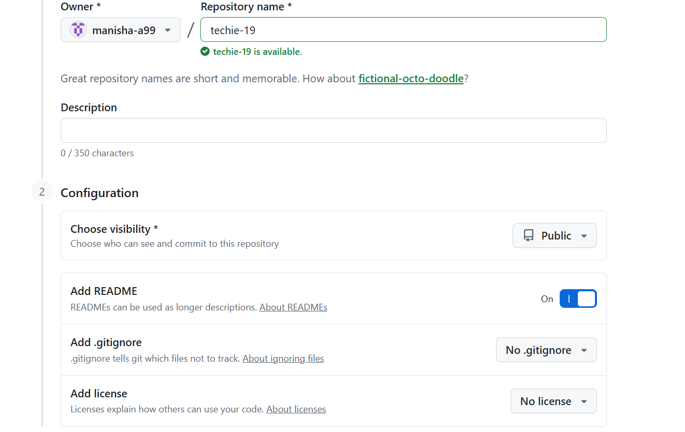

- Clone the created repo to local.
git clone <url>
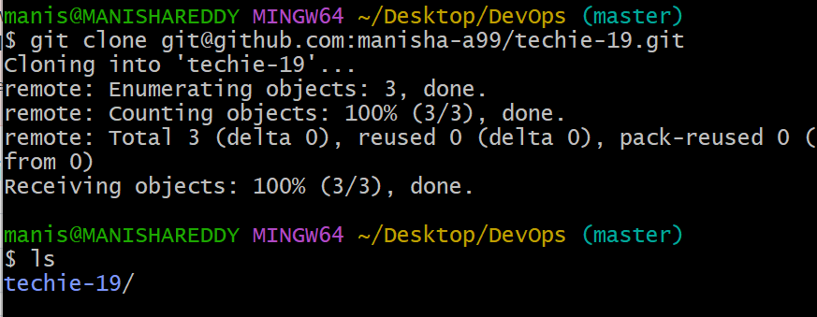

4.Create two files in local repo.
I have created two files using touch command and gave ls to view the files.
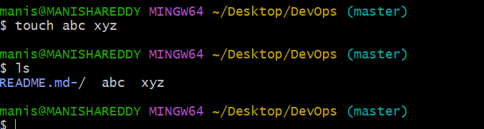
5.Commit two files and push to central Repository.
I have commited two files abc and xyz.
I used git add to add them to tracking area
Git commit -m – to commit the files
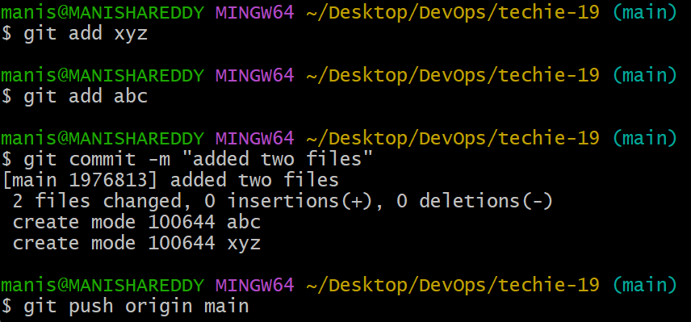
I have checked the files in github
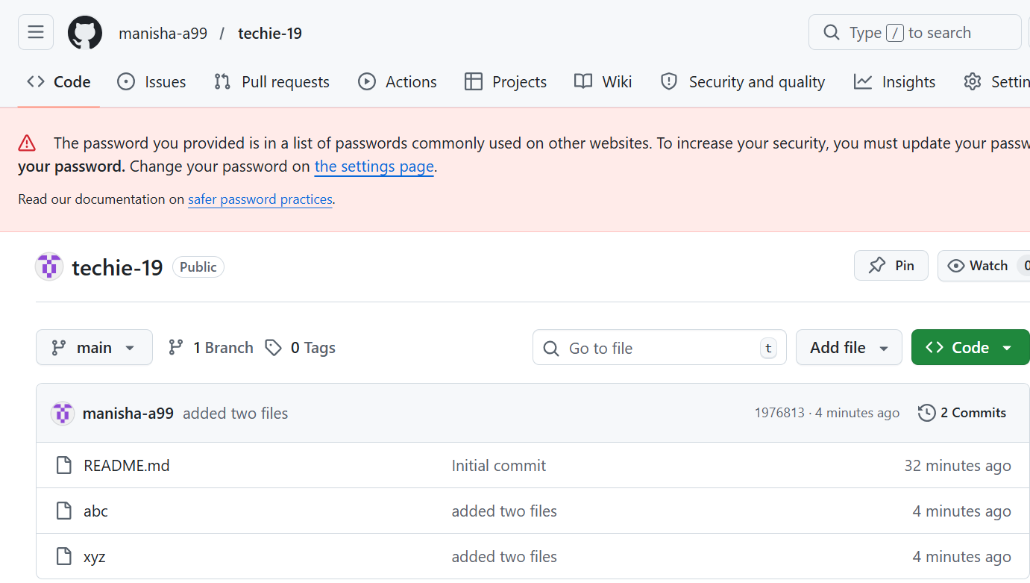
6.Create a branch in local and create a sample file and push to central.
I have created a branch “release” in local
git branch release
Next changed the branch from main to release
git checkout release
I have viewed list of branches as * represents current branch
Git branch --list
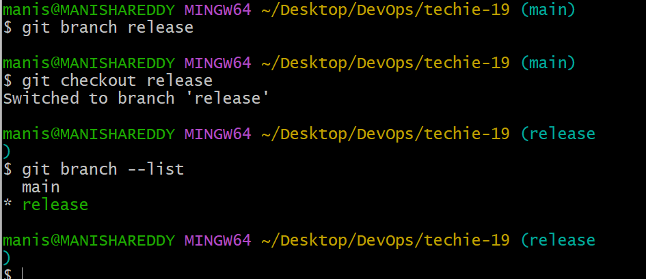
I have created a sample file in release using touch command
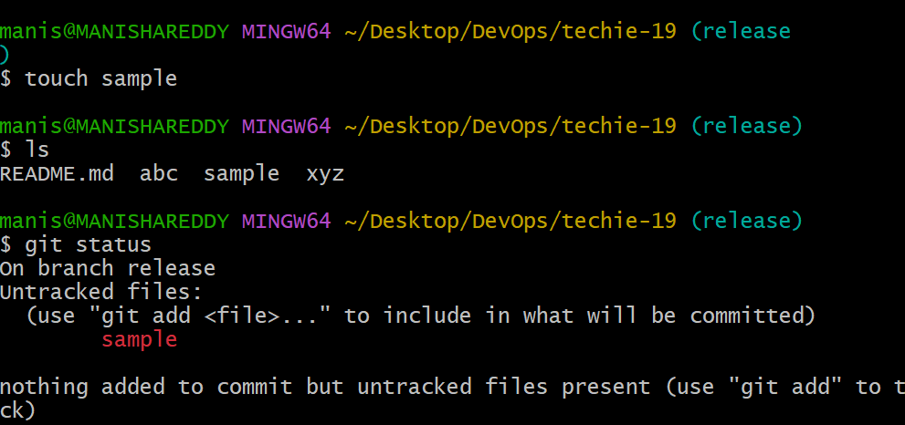
I have added file to targeted area and committed a file.
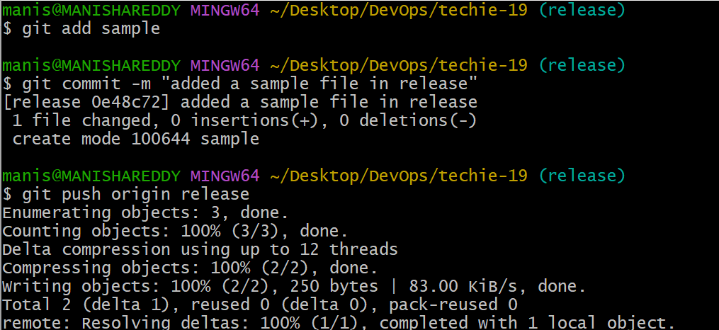
I have pushed the file to central
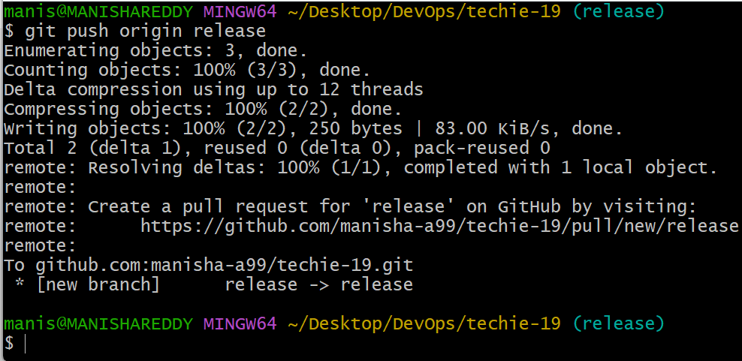

I have viewed file in github
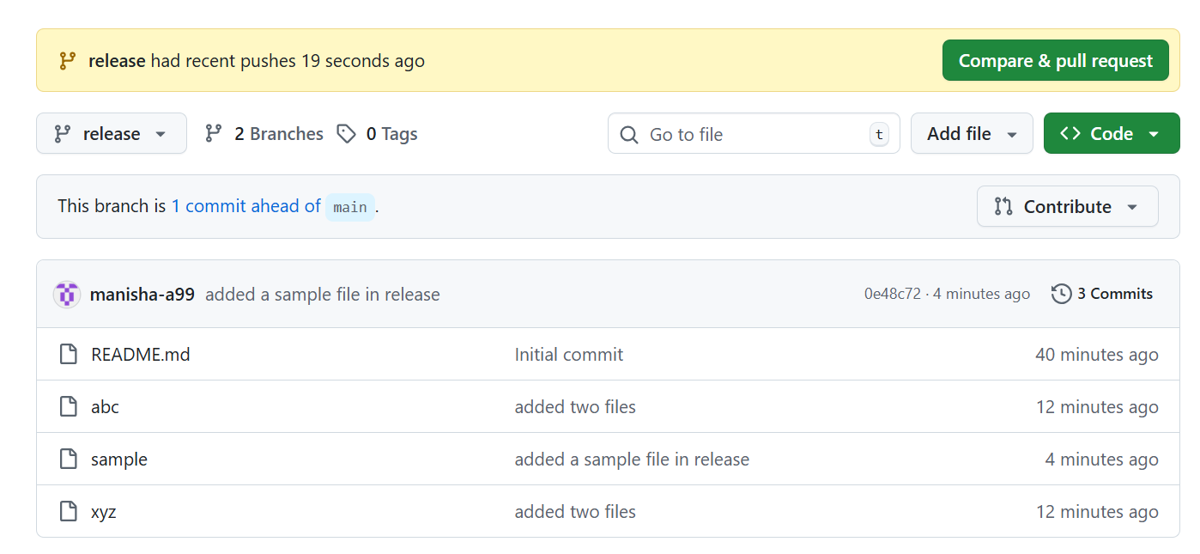
7. Create a branch in github and clone that to local.
I have created a branch Hotfix
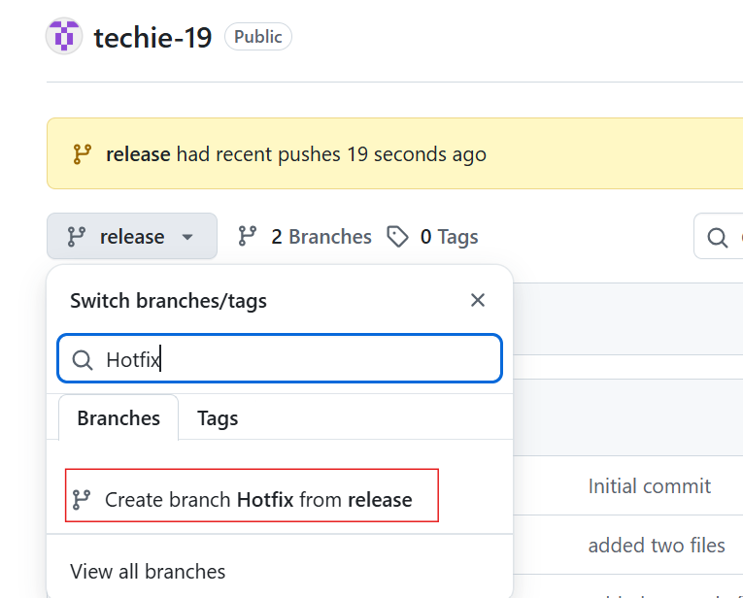
Branch created successfully
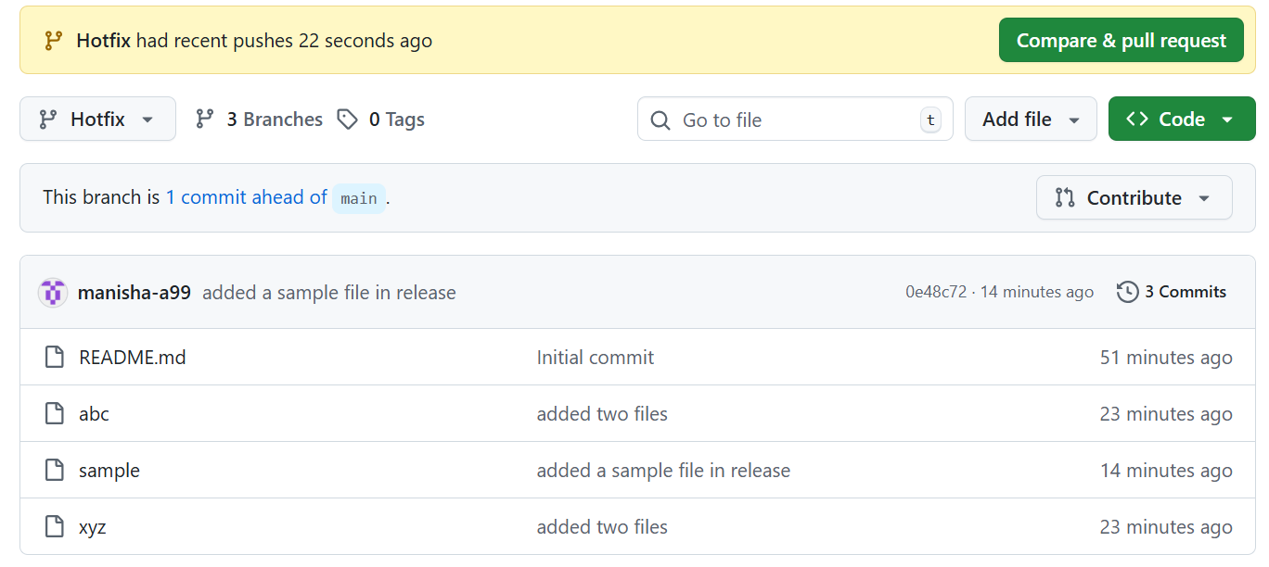
I have fetched the branch from github
Git fetch
Git checkout hotfix

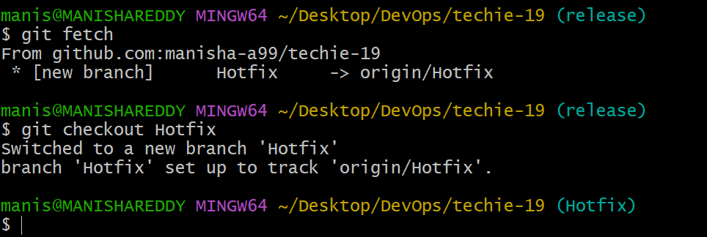

8.Merge the created branch with master in git local.
Git merge main
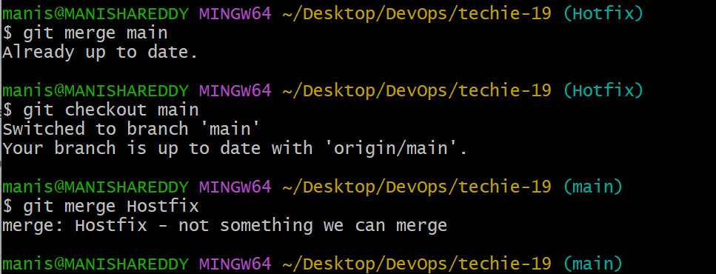

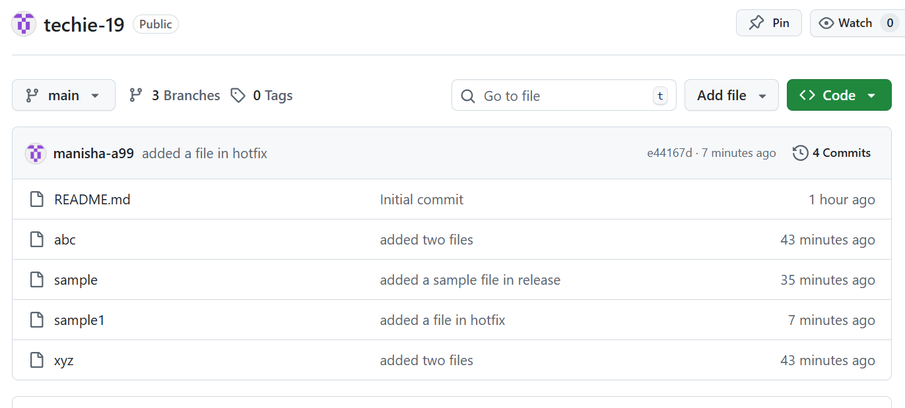
9. Merge the created branch with master in github by sending a pull request.

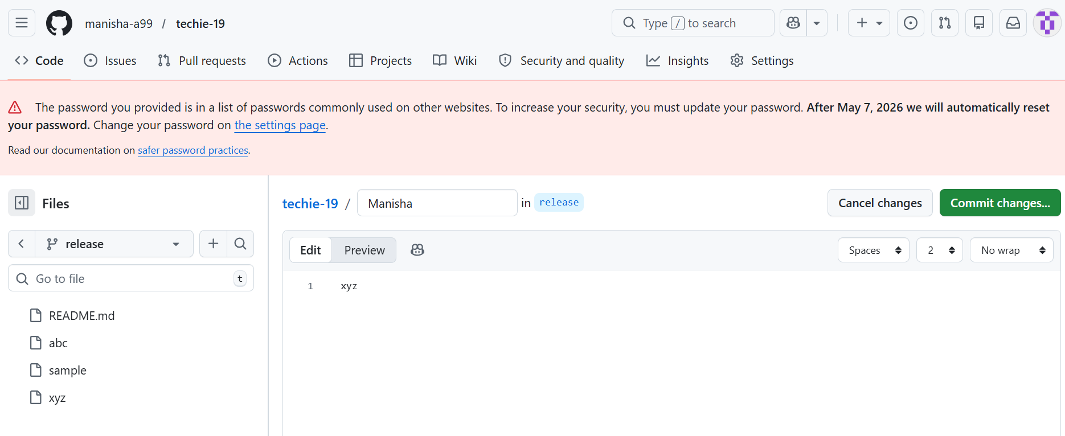
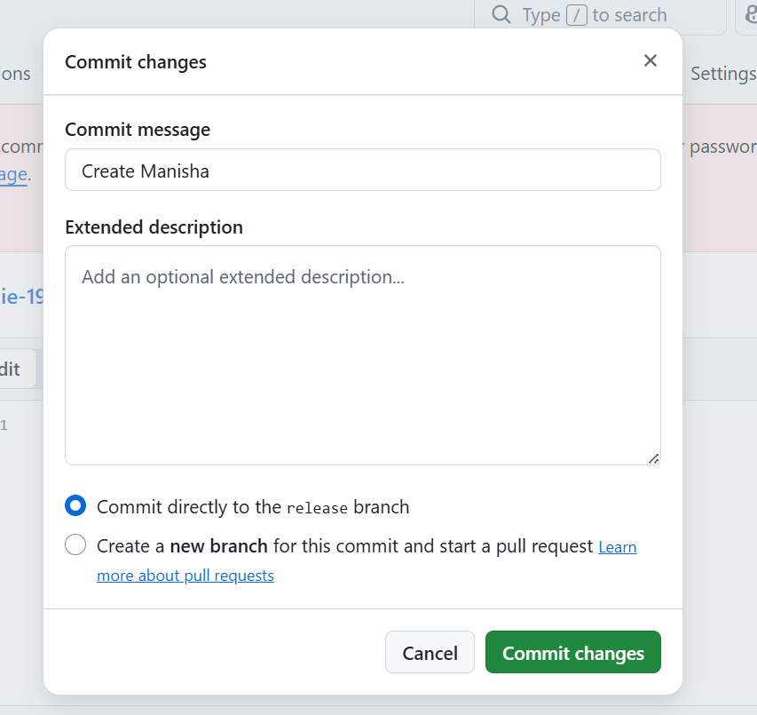

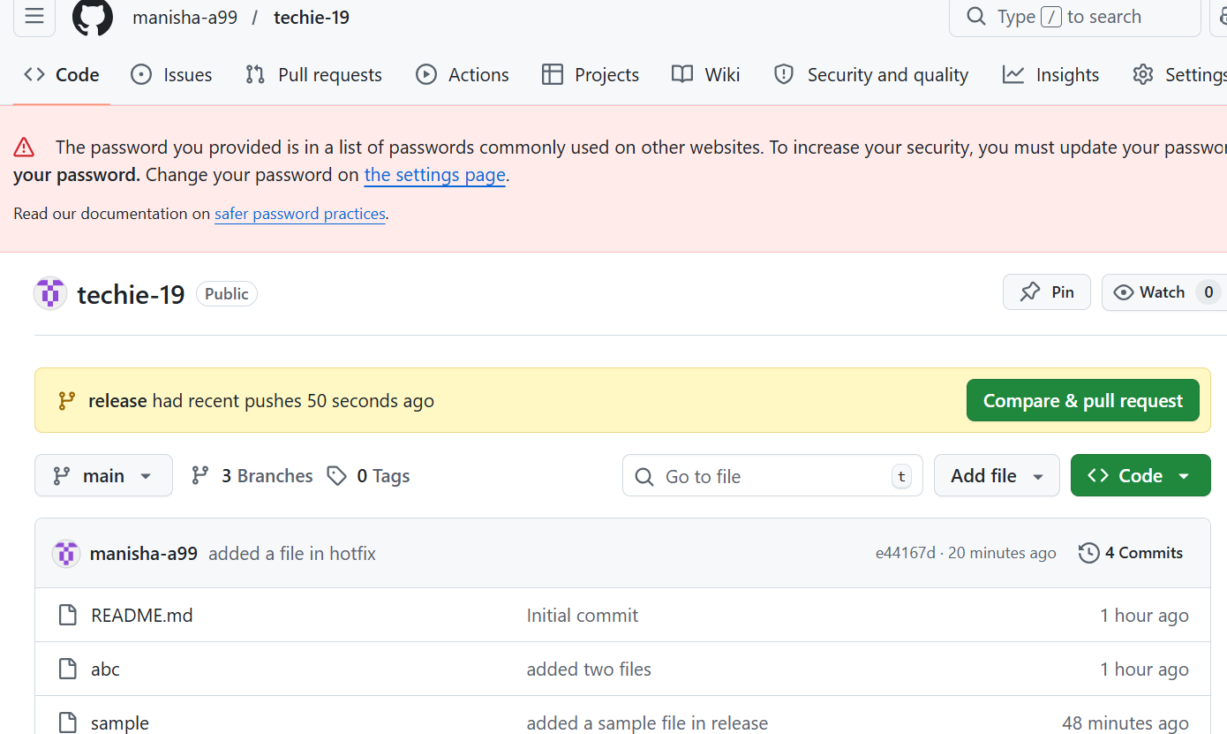
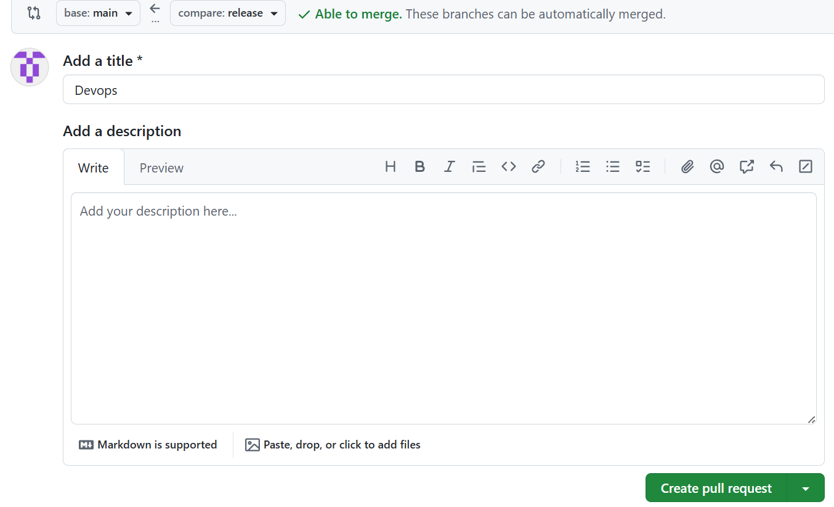
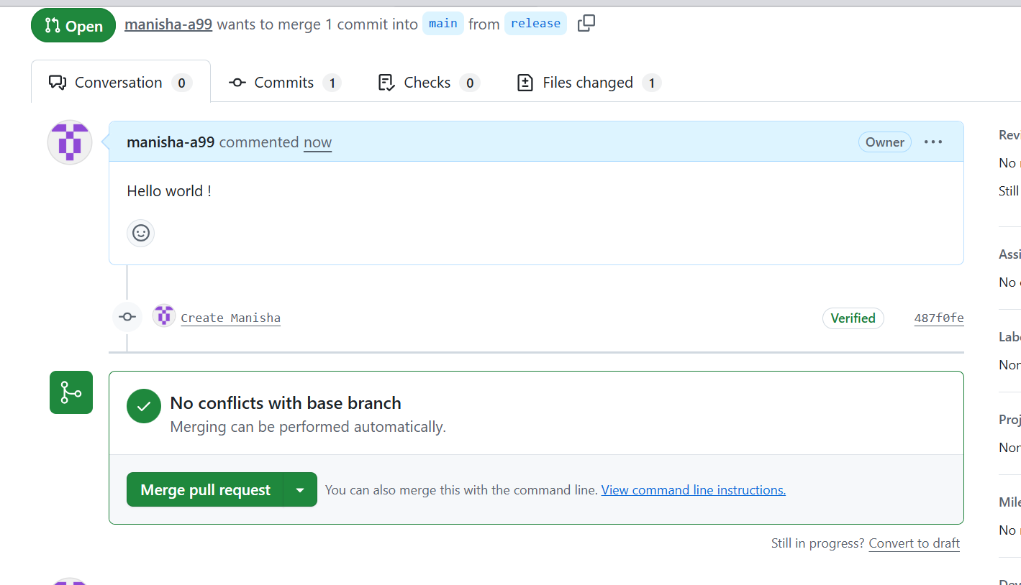
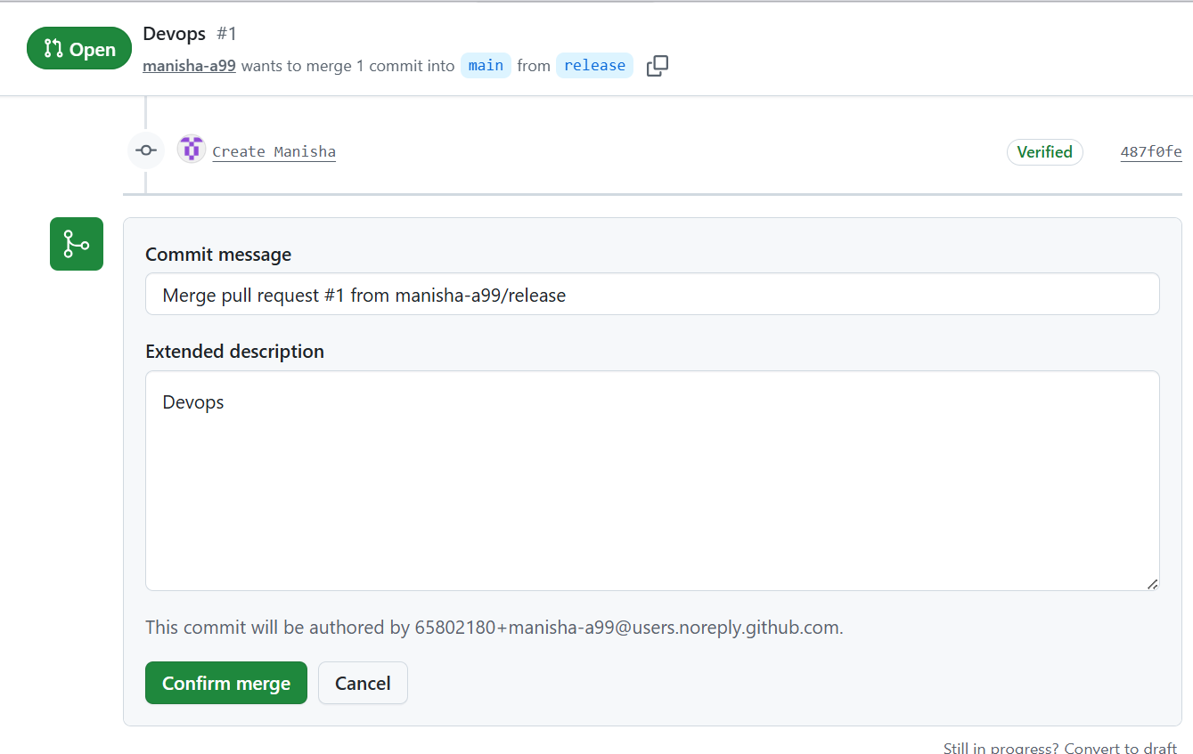
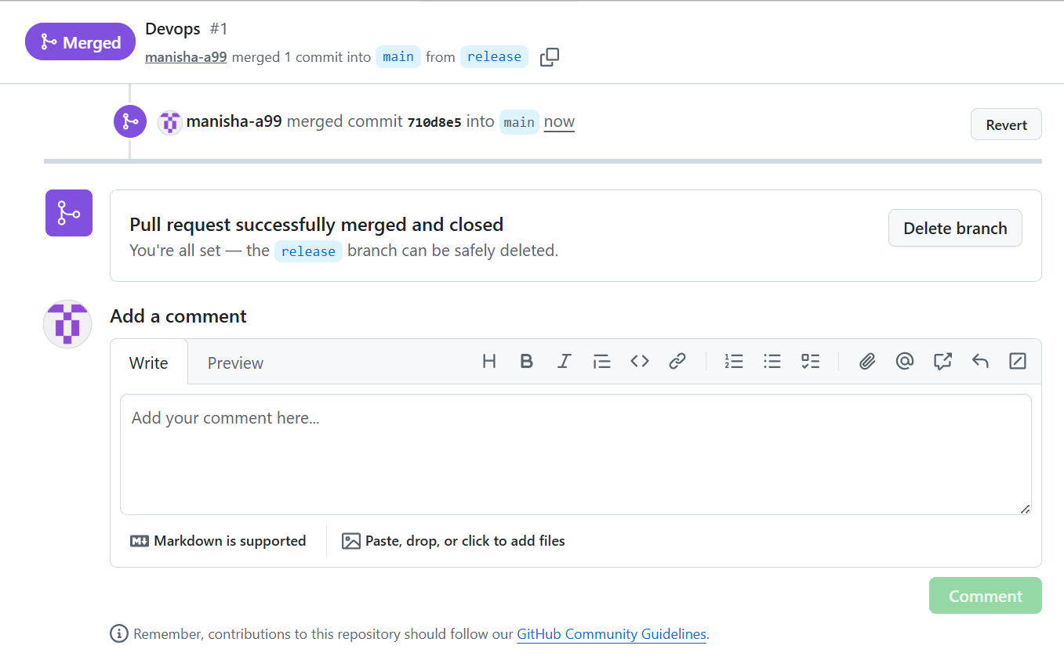
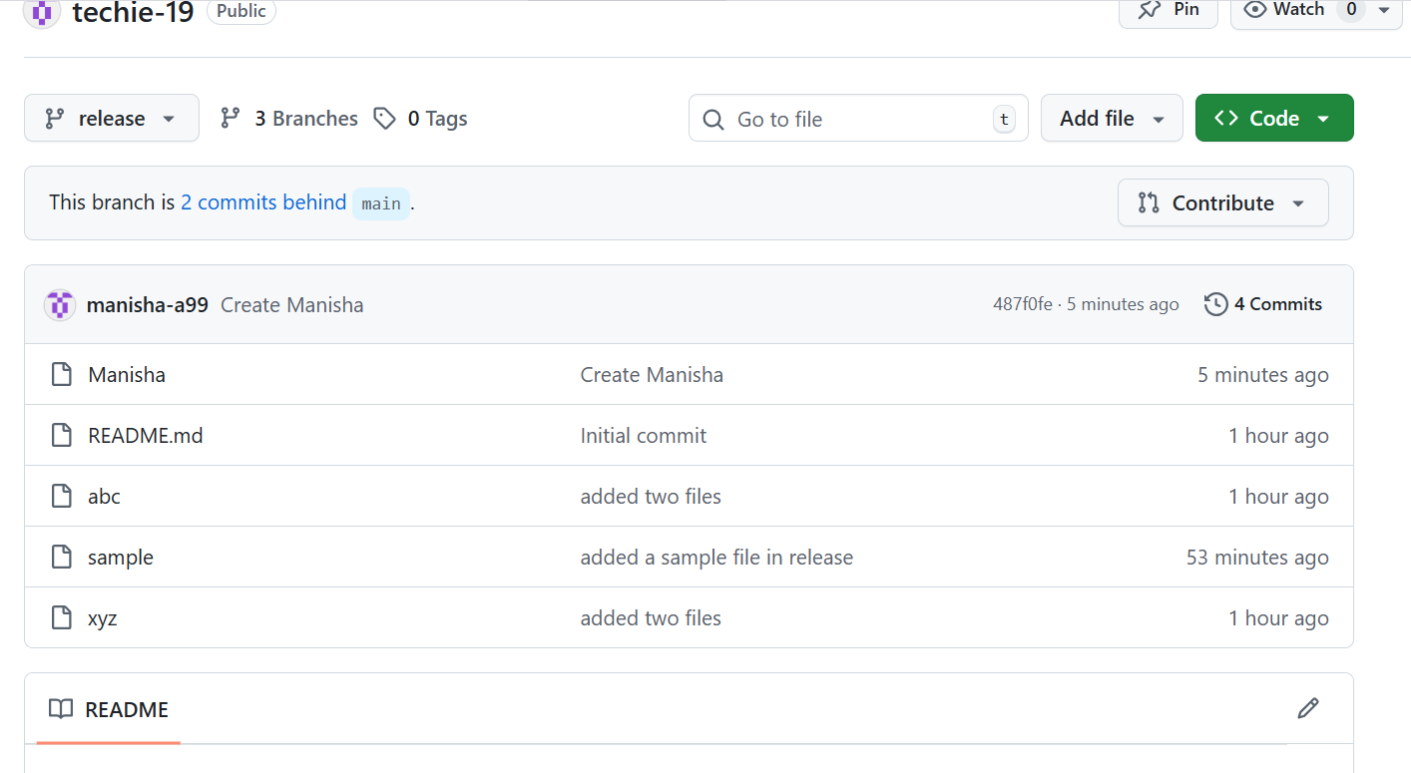
10. Create a file in local and send that to branch in github.
Created a file and sent it to Hotfix branch

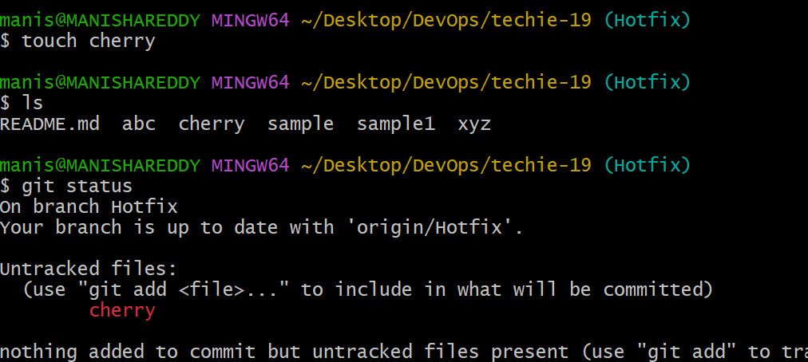
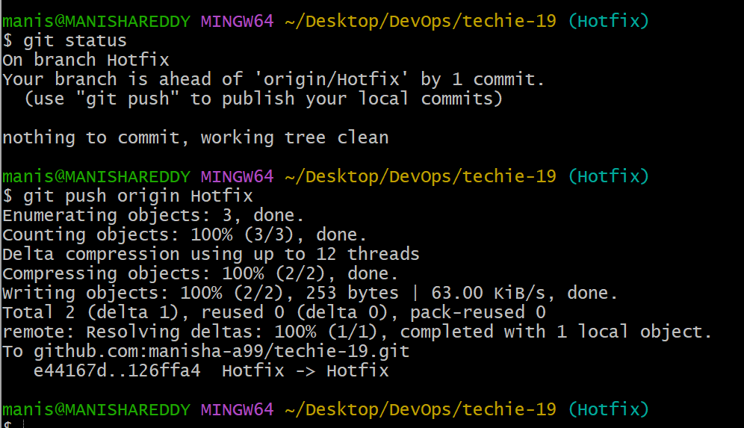
I have checked in github whether the file is updated or not
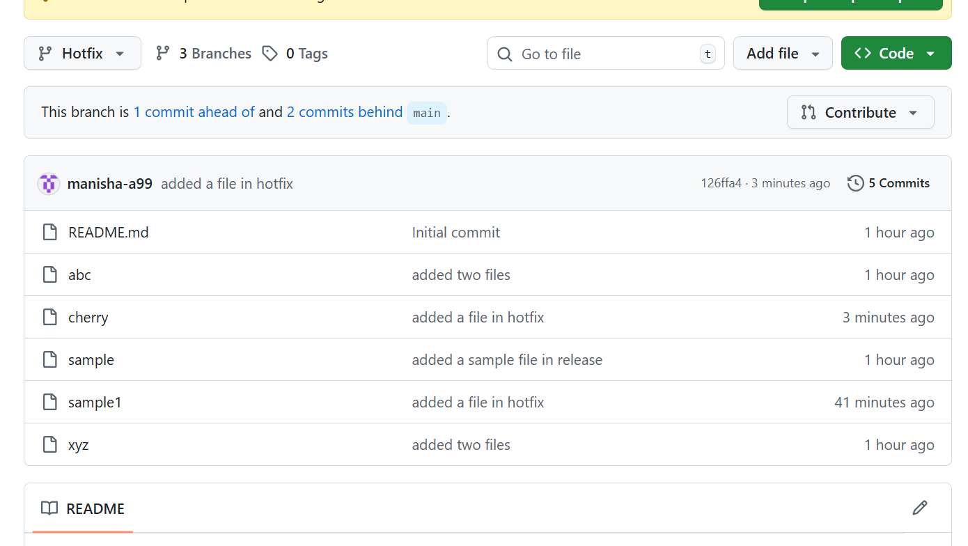
11. Clone only a branch from github to local.
I am cloning release branch from github
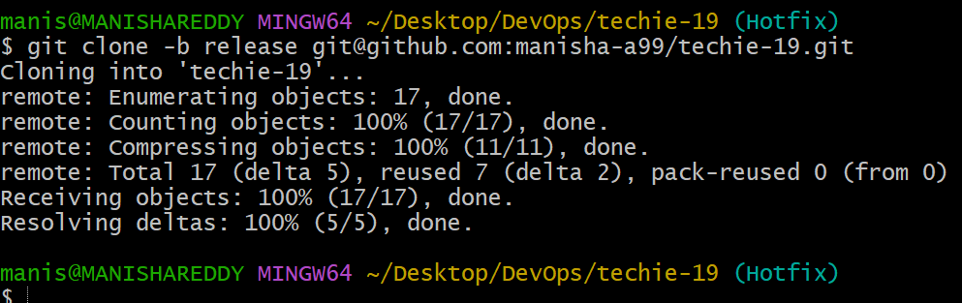
I have checked whether the branch is cloned or not
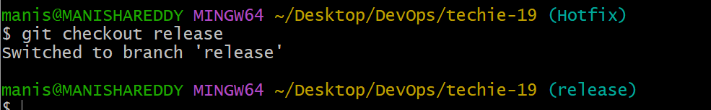
12. Create a file with all passwords and make that untrackable with git.
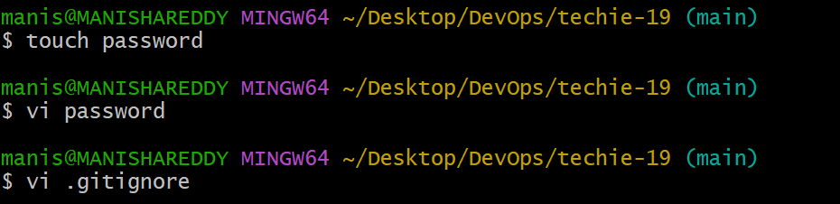
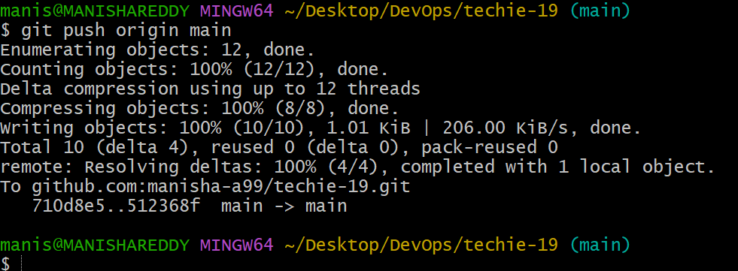
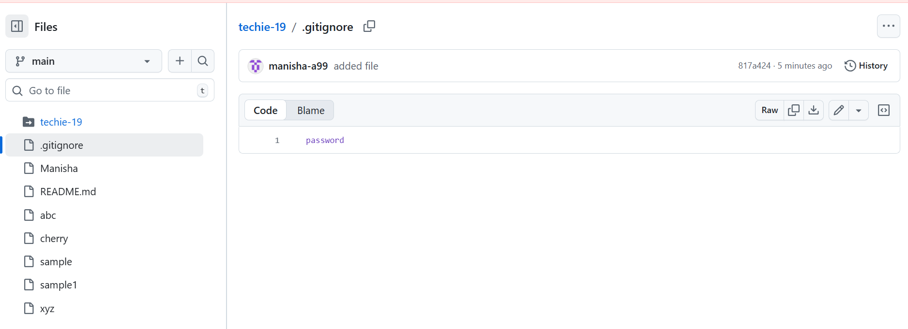

13. Make a commit and make that commit reset without savings changes.
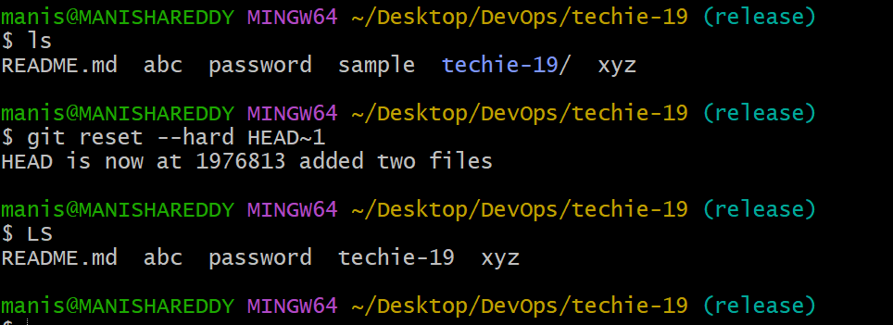
14. Revert a commited commit to the older version.
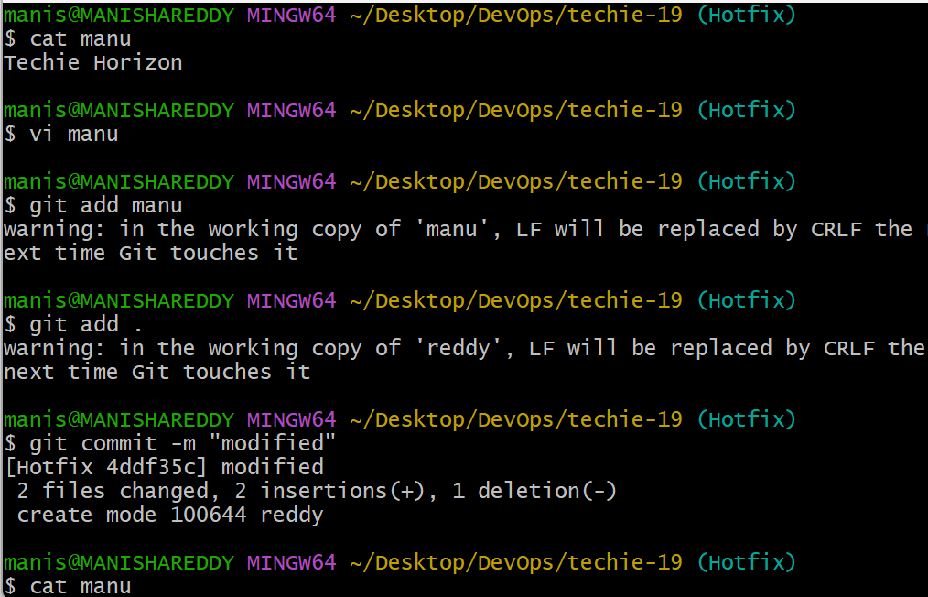
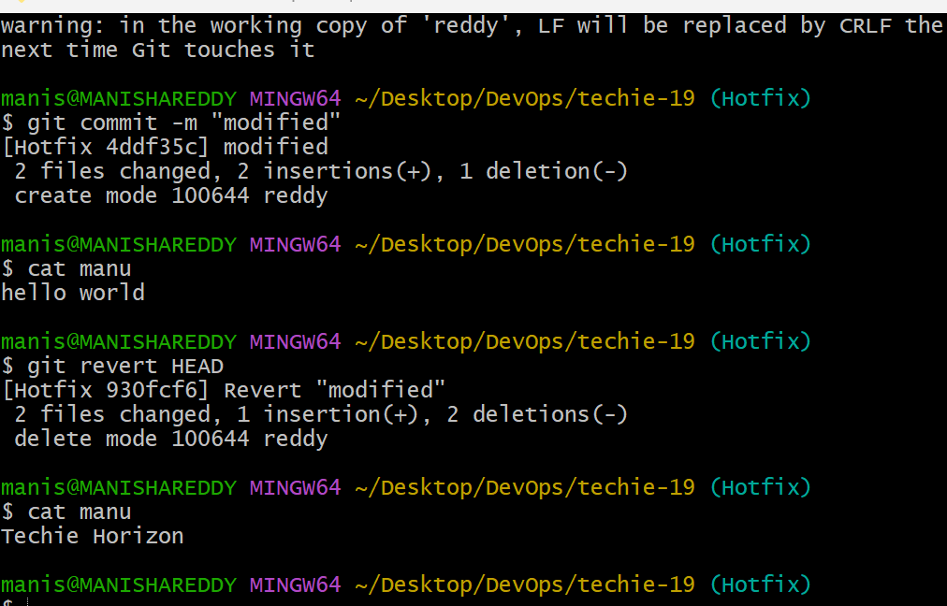

15. Push a file to stash without saving the changes and work on another file.
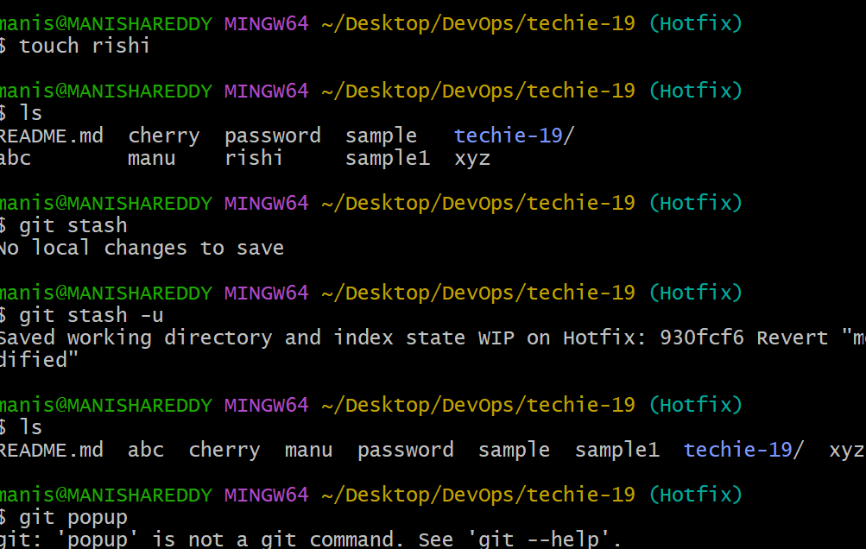
16.Undo the stash file and start working on that again
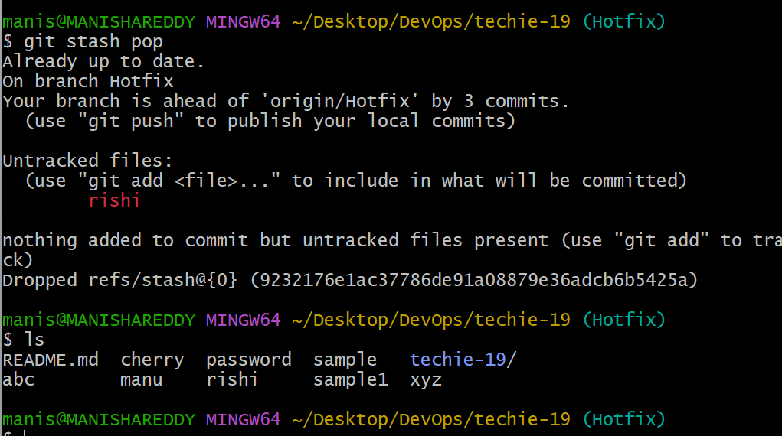

17. Generate a SSH keygen and configure in Github.

Ssh-keygen : To generate SSH keygen I have
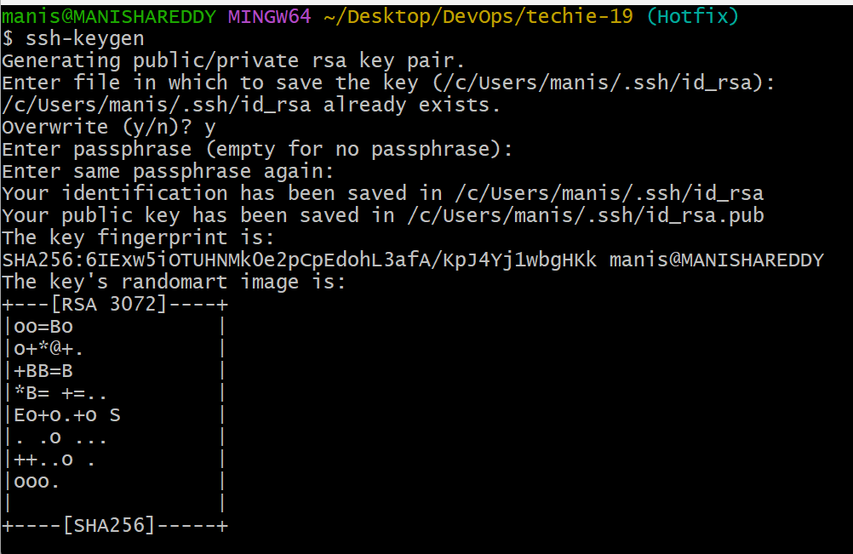

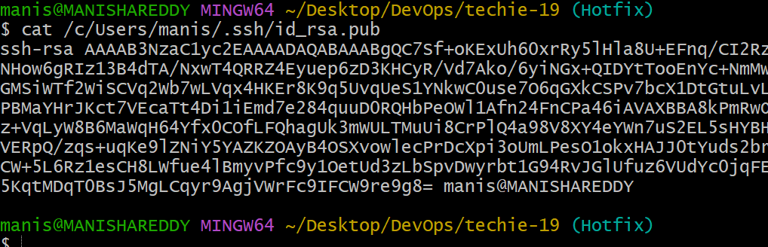
18. Configure webhooks to github.
Go to repositories settings and click on webhooks
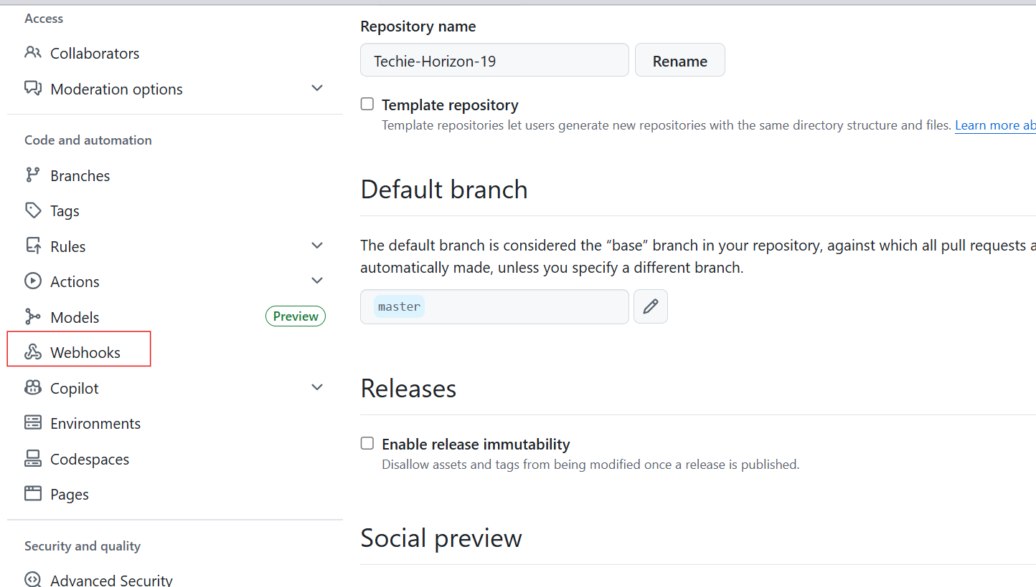
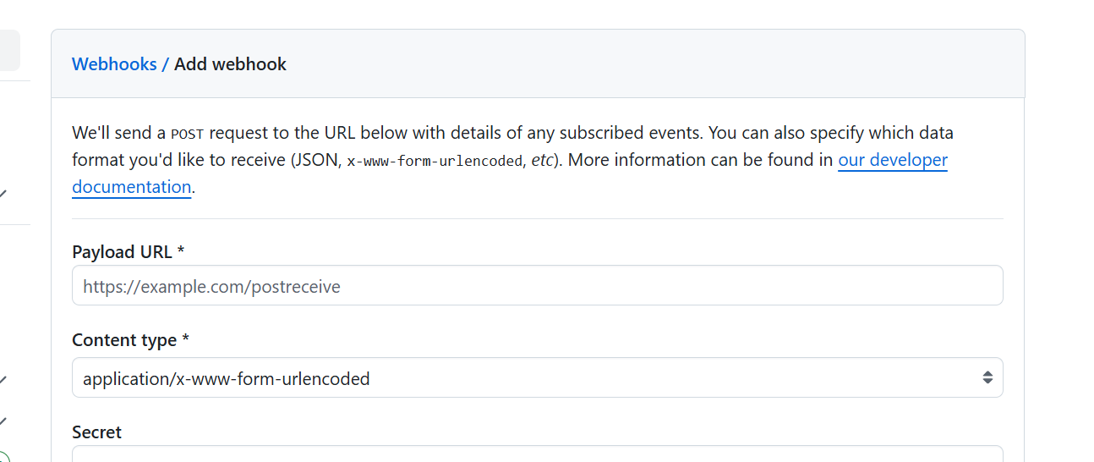
19. Basic understanding of .git directory
.git is a hidden directory when we run the below command
Git init
Inside git we will have all the configurations related to our git tool.
It will help us to get the complete details like username,user details and some default details
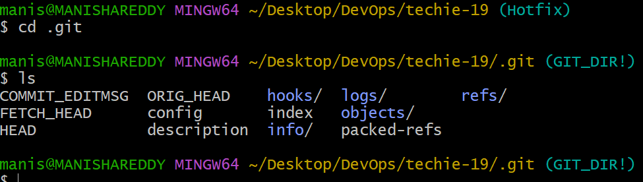
20. Check all the logs of git.
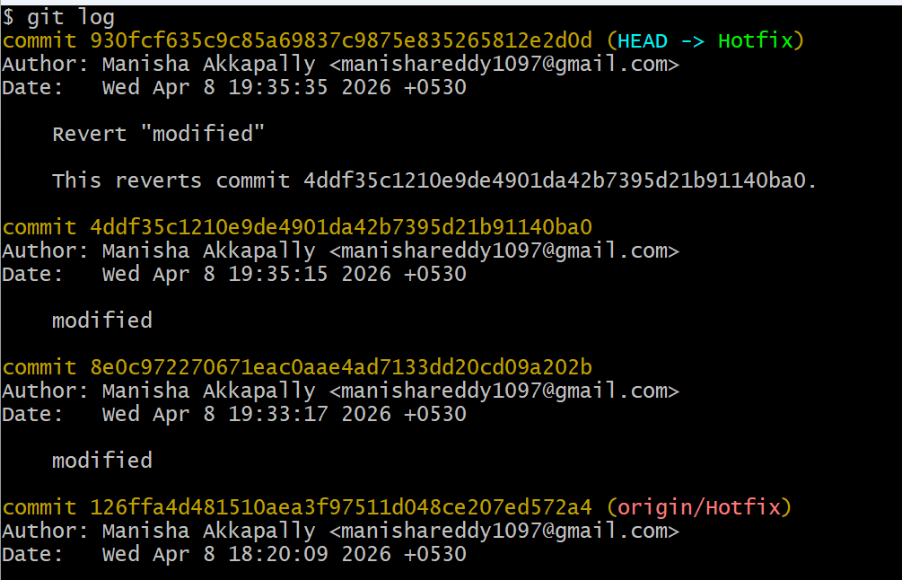
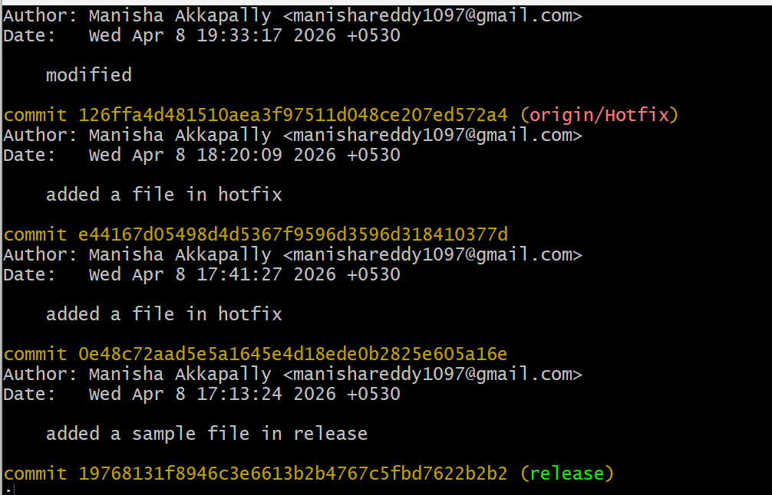
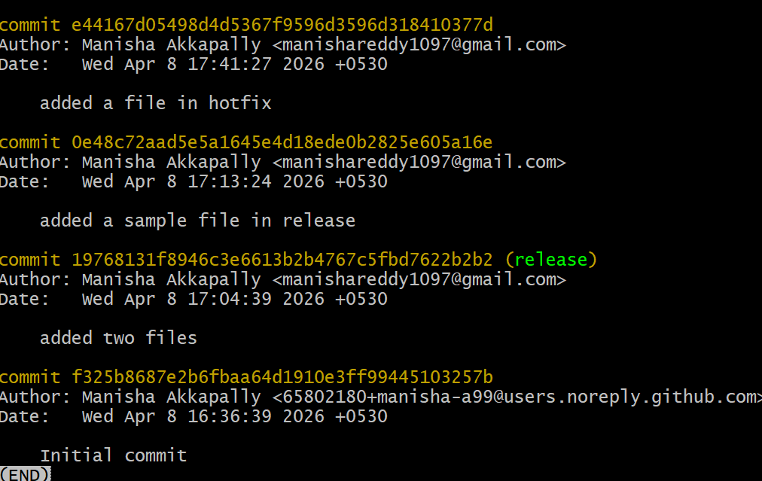
21. Rename the commit message.
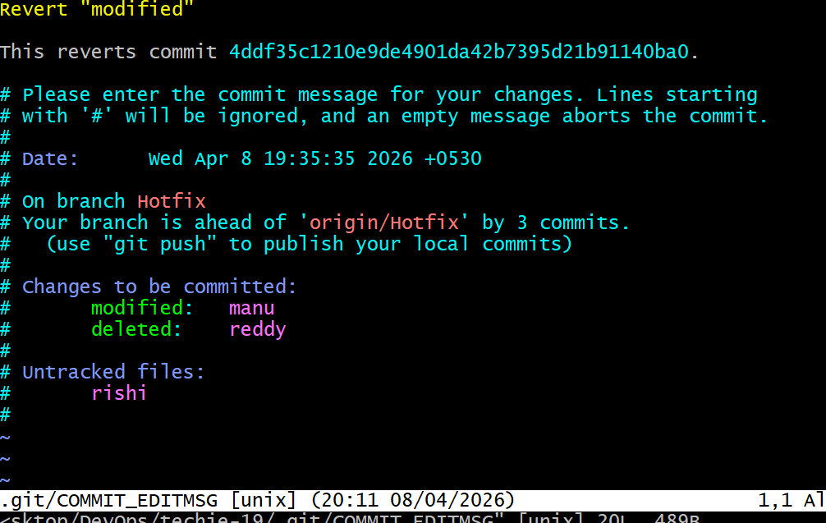

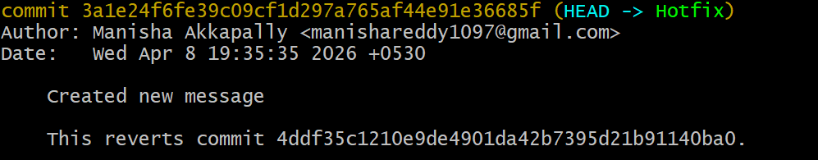

22. Merge multiple commits into single commit.

